Topic : Library Management System  
You are going to build a project based on Library Management System. It keeps track of all information about books in the library, their cost, status and total number of books available in the library.  
  
Create a database named library and following TABLES in the database:   
  
1. Branch   
2. Employee   
3. Books  
4. Customer  
5. IssueStatus  
6. ReturnStatus   
  
Attributes for the tables:   
  
1. Branch  
  
• Branch_no

* Set as PRIMARY KEY    
  • Manager_Id    
  • Branch_address    
  • Contact_no

2. Employee    
  
• Emp_Id – Set as PRIMARY KEY    
• Emp_name    
• Position    
• Salary  
• Branch_no

* Set as FOREIGN KEY and it refer Branch_no in Branch table

3. Books    
  
• ISBN

* Set as PRIMARY KEY    
  • Book_title    
  • Category    
  • Rental_Price    
  • Status [Give yes if book available and no if book not available]    
  • Author    
  • Publisher

4. Customer    
  
• Customer_Id

* Set as PRIMARY KEY    
  • Customer_name    
  • Customer_address    
  • Reg_date

5. IssueStatus    
  
• Issue_Id

* Set as PRIMARY KEY    
  • Issued_cust – Set as FOREIGN KEY and it refer customer_id in CUSTOMER table  Issued_book_name   
  • Issue_date   
  • Isbn_book – Set as FOREIGN KEY and it should refer isbn in BOOKS table

6. ReturnStatus    
  
• Return_Id

* Set as PRIMARY KEY    
  • Return_cust    
  • Return_book_name    
  • Return_date    
  • Isbn_book2
* Set as FOREIGN KEY and it should refer isbn in BOOKS table

-- Create the database

CREATE DATABASE library;

-- Use the library database

USE library;

-- Create Branch table

CREATE TABLE Branch (

Branch_no INT PRIMARY KEY,

Manager_Id INT,

Branch_address VARCHAR(255),

Contact_no VARCHAR(15)

);

-- Create Employee table

CREATE TABLE Employee (

Emp_Id INT PRIMARY KEY,

Emp_name VARCHAR(100),

Position VARCHAR(100),

Salary DECIMAL(10, 2),

Branch_no INT,

FOREIGN KEY (Branch_no) REFERENCES Branch(Branch_no)

);

-- Create Books table

CREATE TABLE Books (

ISBN VARCHAR(20) PRIMARY KEY,

Book_title VARCHAR(255),

Category VARCHAR(100),

Rental_Price DECIMAL(10, 2),

Status VARCHAR(3) CHECK (Status IN ('yes', 'no')),

Author VARCHAR(100),

Publisher VARCHAR(100)

);

-- Create Customer table

CREATE TABLE Customer (

Customer_Id INT PRIMARY KEY,

Customer_name VARCHAR(100),

Customer_address VARCHAR(255),

Reg_date DATE

);

-- Create IssueStatus table

CREATE TABLE IssueStatus (

Issue_Id INT PRIMARY KEY,

Issued_cust INT,

Issued_book_name VARCHAR(255),

Issue_date DATE,

Isbn_book VARCHAR(20),

FOREIGN KEY (Issued_cust) REFERENCES Customer(Customer_Id),

FOREIGN KEY (Isbn_book) REFERENCES Books(ISBN)

);

-- Create ReturnStatus table

CREATE TABLE ReturnStatus (

Return_Id INT PRIMARY KEY,

Return_cust INT,

Return_book_name VARCHAR(255),

Return_date DATE,

Isbn_book2 VARCHAR(20),

FOREIGN KEY (Return_cust) REFERENCES Customer(Customer_Id),

FOREIGN KEY (Isbn_book2) REFERENCES Books(ISBN)

);

-- Insert data into Branch table

INSERT INTO Branch VALUES

(1, 101, '123 Library St, City A', '1234567890'),

(2, 102, '456 Book Ln, City B', '0987654321');

-- Insert data into Employee table

INSERT INTO Employee VALUES

(1, 'Alice Smith', 'Manager', 60000, 1),

(2, 'Bob Johnson', 'Assistant', 40000, 1),

(3, 'Charlie Davis', 'Librarian', 45000, 2),

(4, 'David Harris', 'Manager', 70000, 2);

-- Insert data into Books table

INSERT INTO Books VALUES

('978-3-16-148410-0', 'Book A', 'Fiction', 20.00, 'yes', 'Author A', 'Publisher A'),

('978-1-23-456789-7', 'Book B', 'Non-Fiction', 25.00, 'no', 'Author B', 'Publisher B'),

('978-0-12-345678-9', 'Book C', 'Science', 30.00, 'yes', 'Author C', 'Publisher C');

-- Insert data into Customer table

INSERT INTO Customer VALUES

(1, 'John Doe', '789 Main St, City A', '2020-01-01'),

(2, 'Jane Smith', '456 Side St, City B', '2021-06-15'),

(3, 'Emily Jones', '123 High St, City A', '2023-03-20');

-- Insert data into IssueStatus table

INSERT INTO IssueStatus VALUES

(1, 1, 'Book A', '2023-06-01', '978-3-16-148410-0'),

(2, 2, 'Book C', '2023-06-15', '978-0-12-345678-9');

-- Insert data into ReturnStatus table

INSERT INTO ReturnStatus VALUES

(1, 1, 'Book A', '2023-06-10', '978-3-16-148410-0');

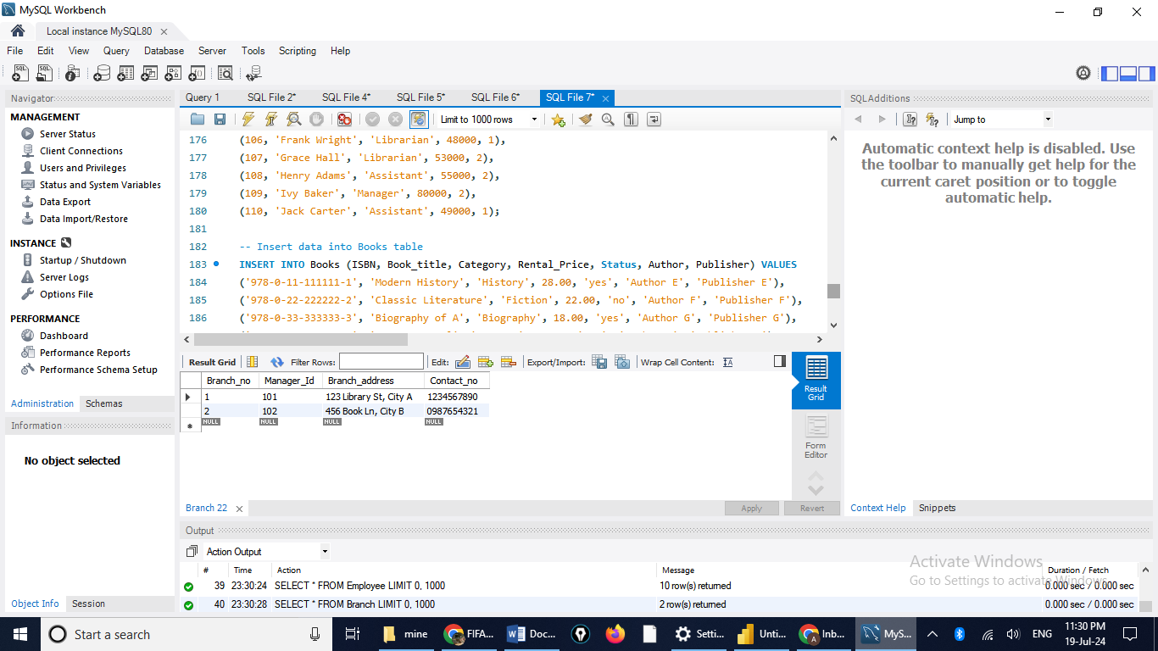  
  
Display all the tables and Write the queries for the following :  
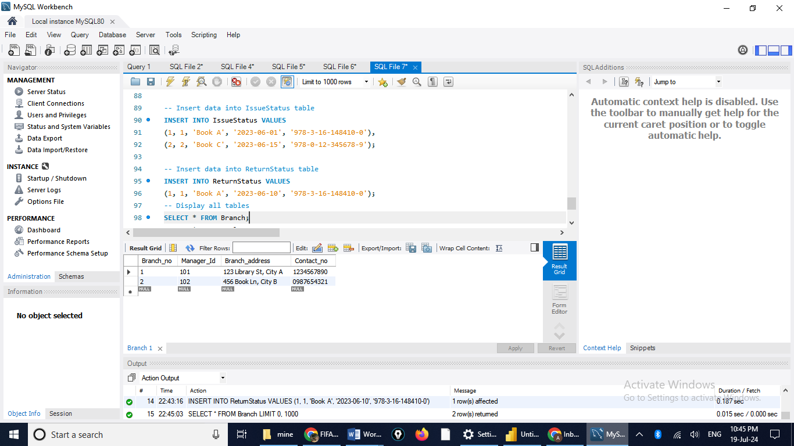

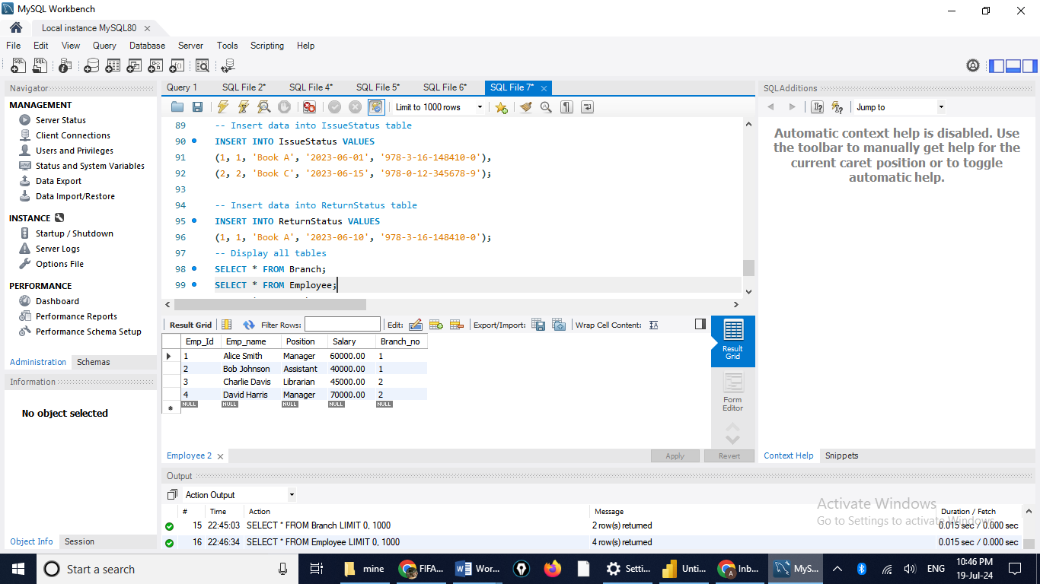

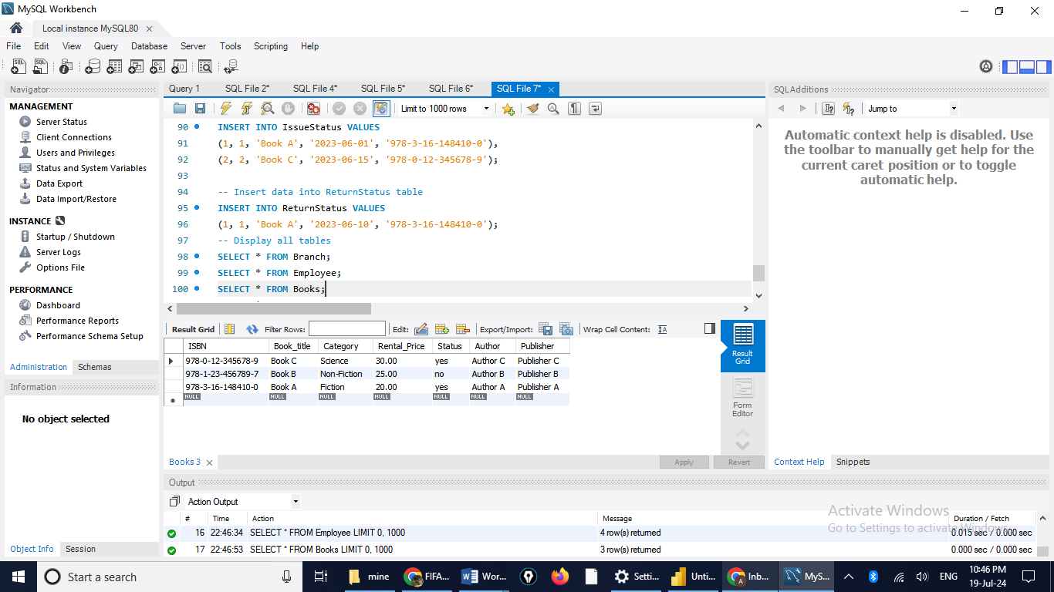

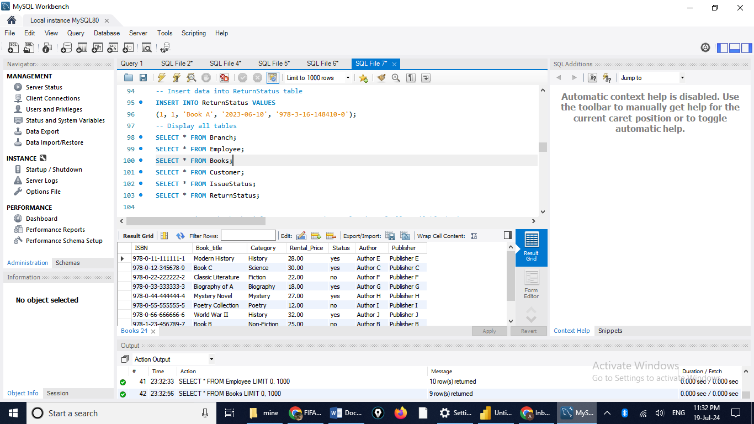

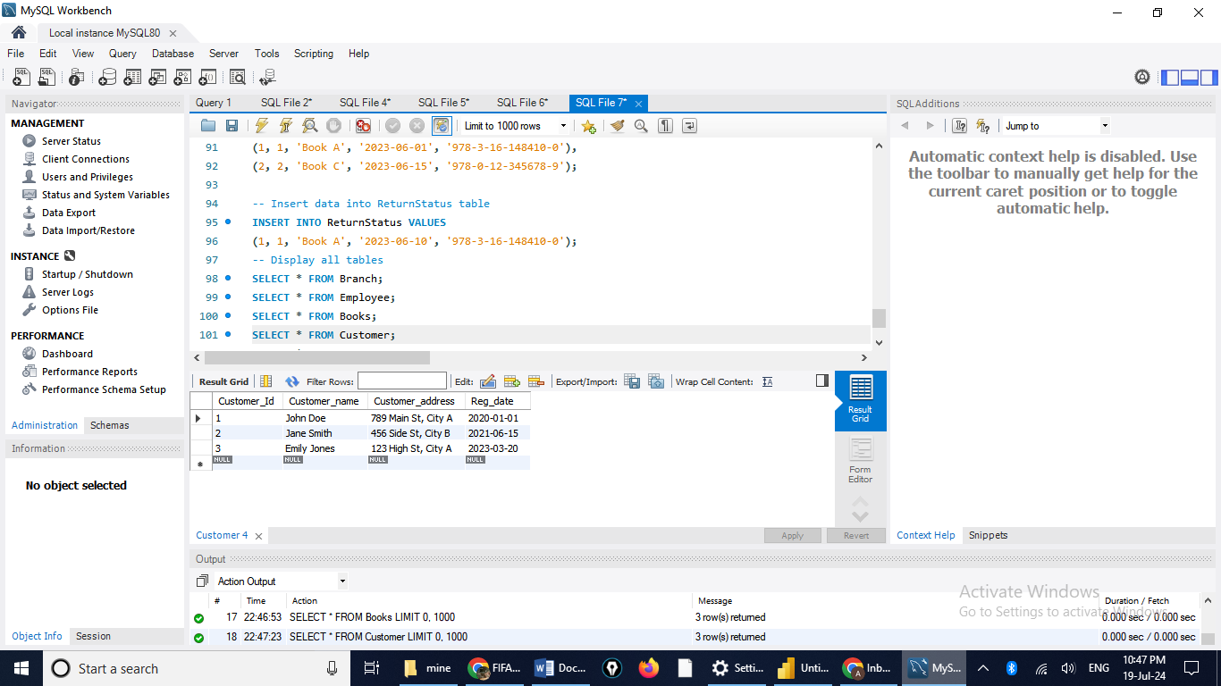

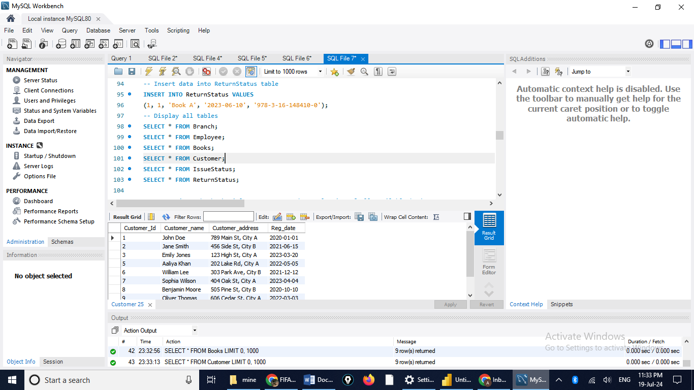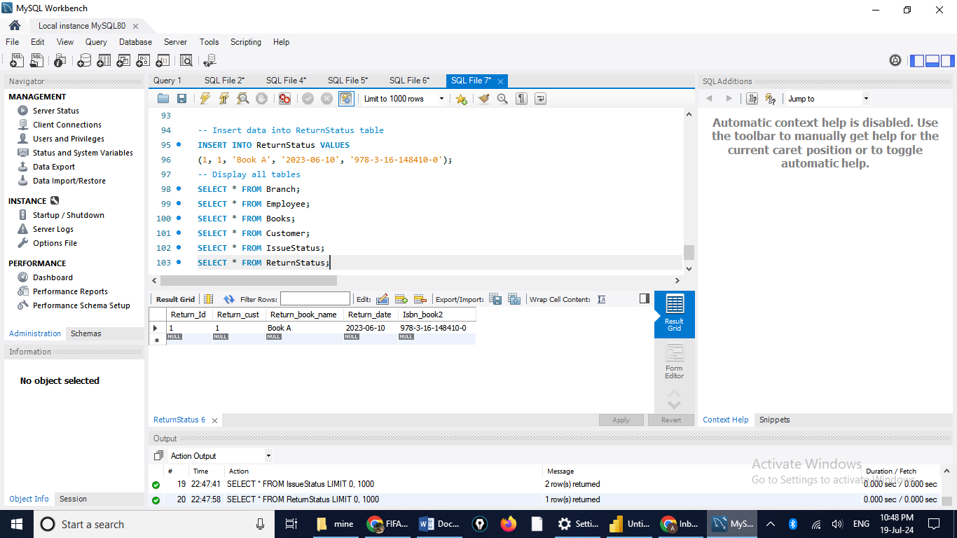  
1. Retrieve the book title, category, and rental price of all available books.

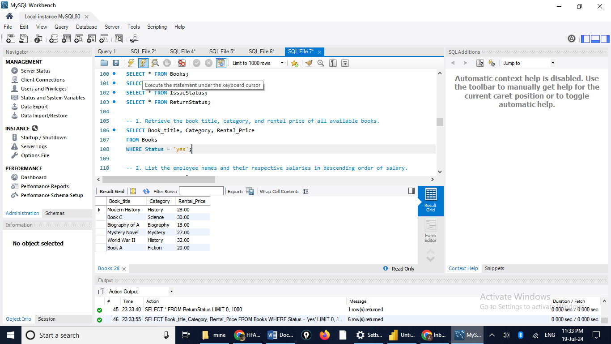  
2. List the employee names and their respective salaries in descending order of salary.

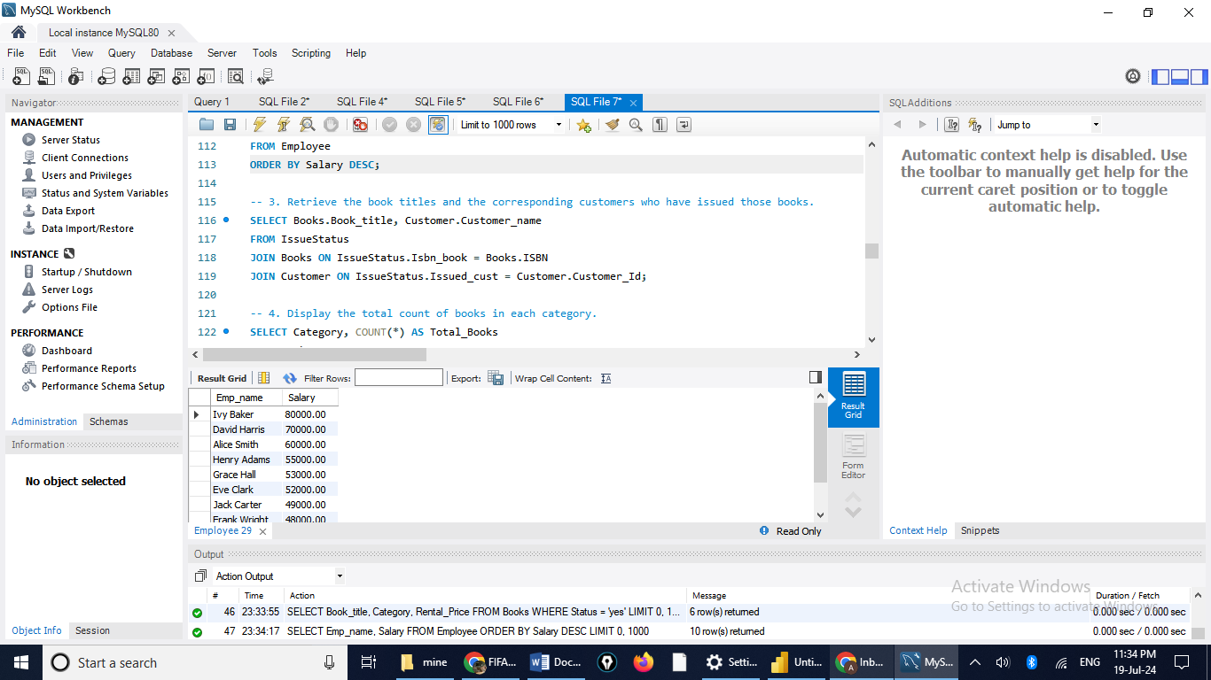  
3. Retrieve the book titles and the corresponding customers who have issued those books.

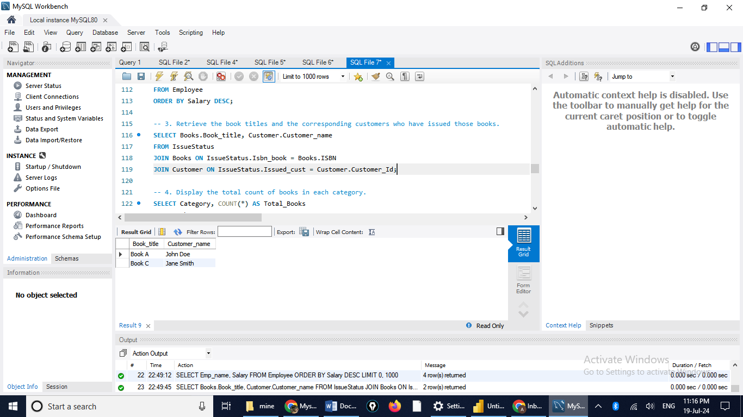   
4. Display the total count of books in each category

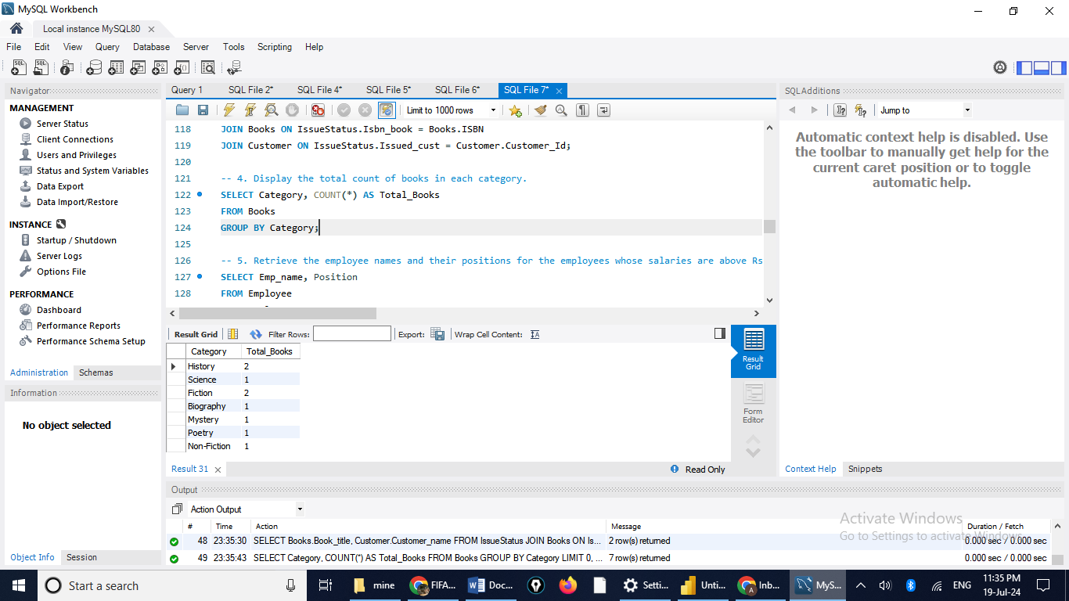.   
5. Retrieve the employee names and their positions for the employees whose salaries are above Rs.50,000.

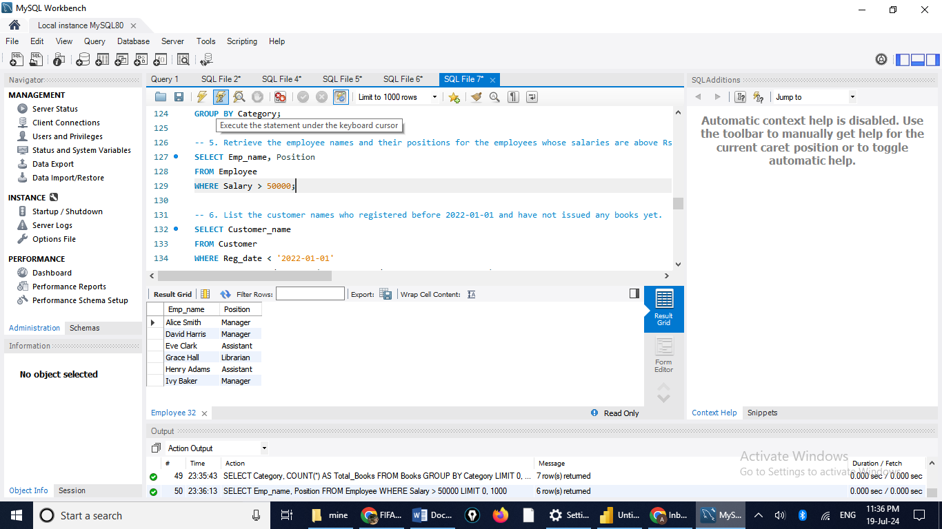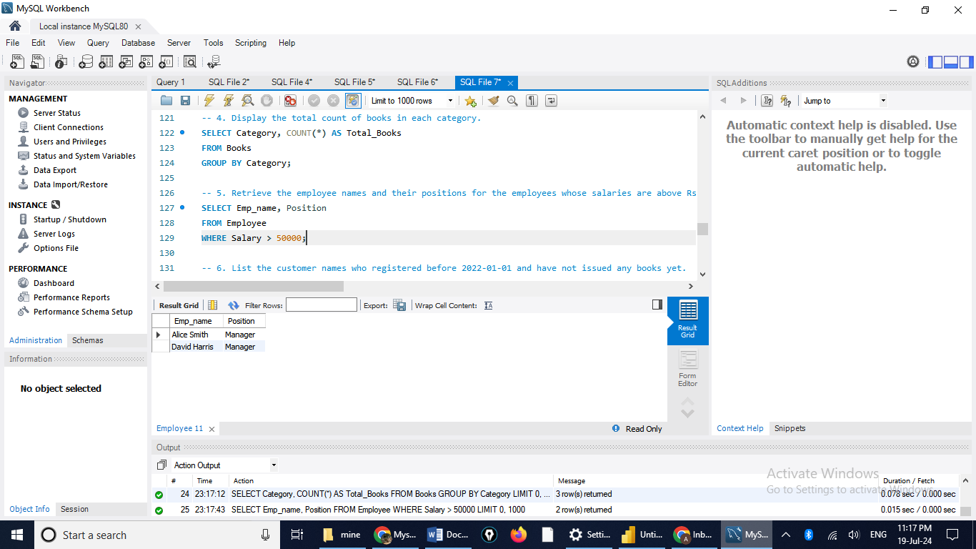  
6. List the customer names who registered before 2022-01-01 and have not issued any books yet.

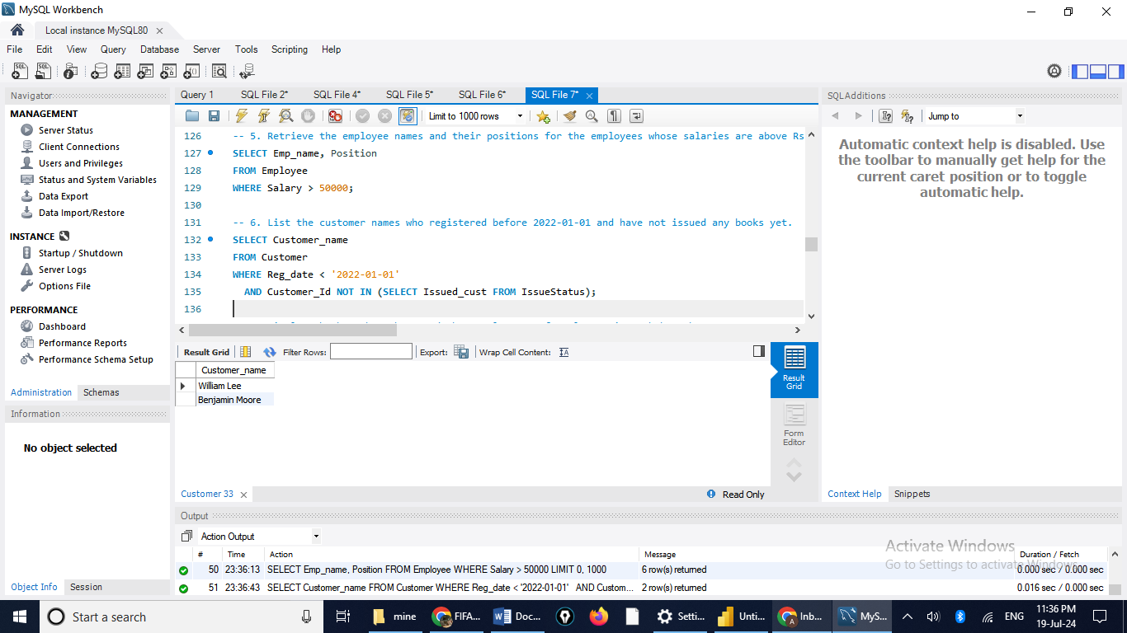  
7. Display the branch numbers and the total count of employees in each branch.

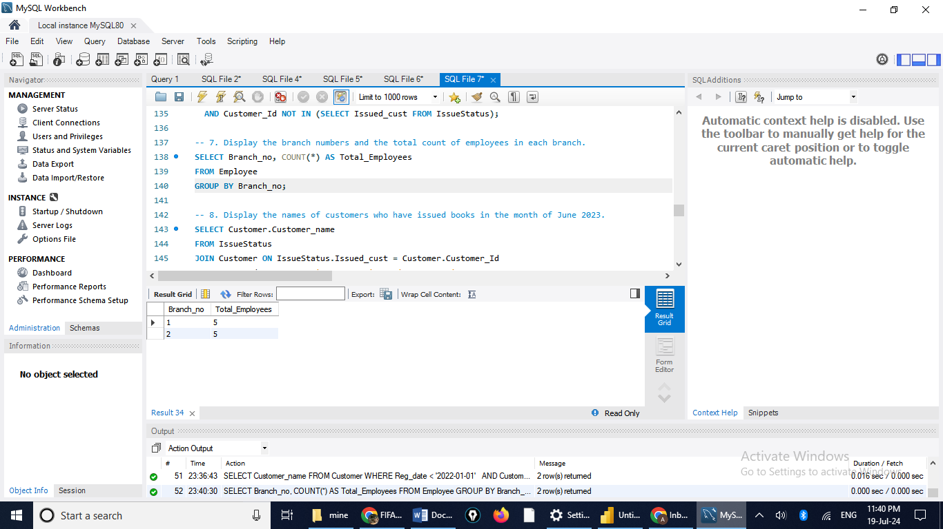  
8. Display the names of customers who have issued books in the month of June 2023.

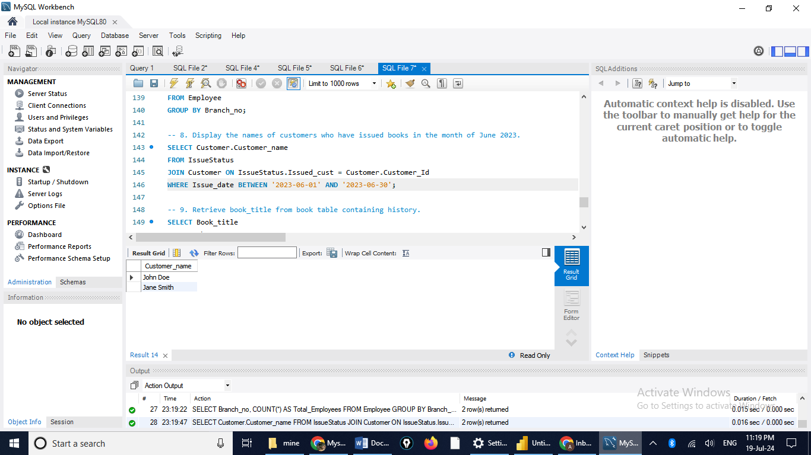  
9. Retrieve book_title from book table containing history.

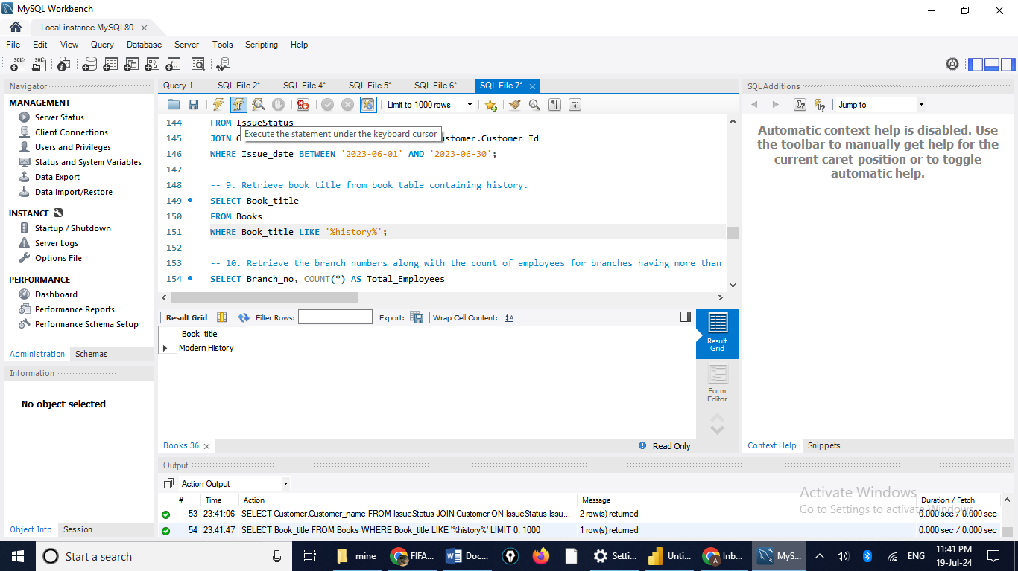  
10.Retrieve the branch numbers along with the count of employees for branches having more than 5 employees

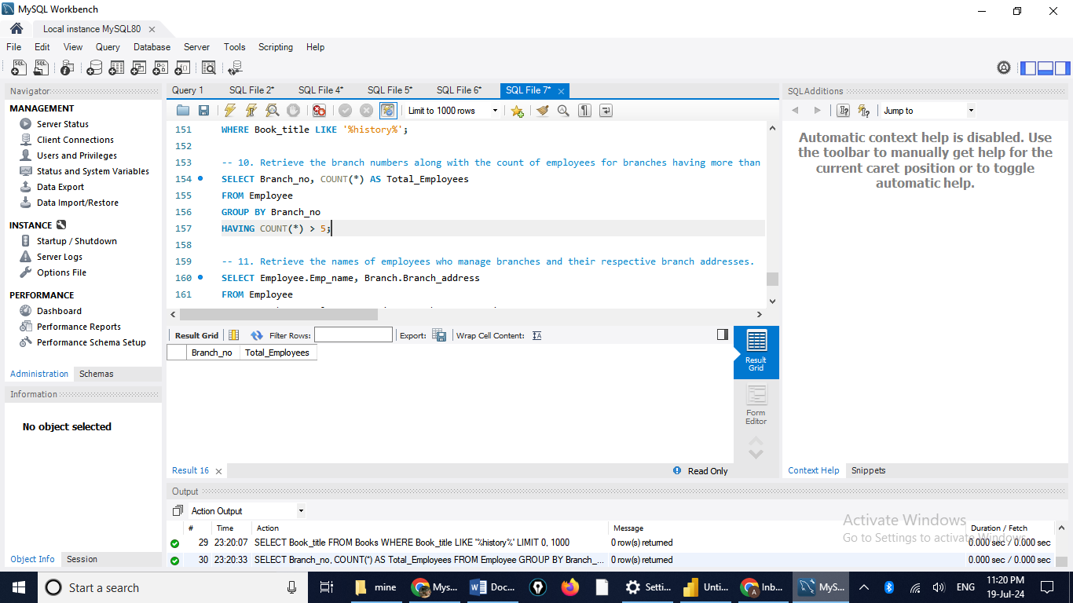

More than 2 employees

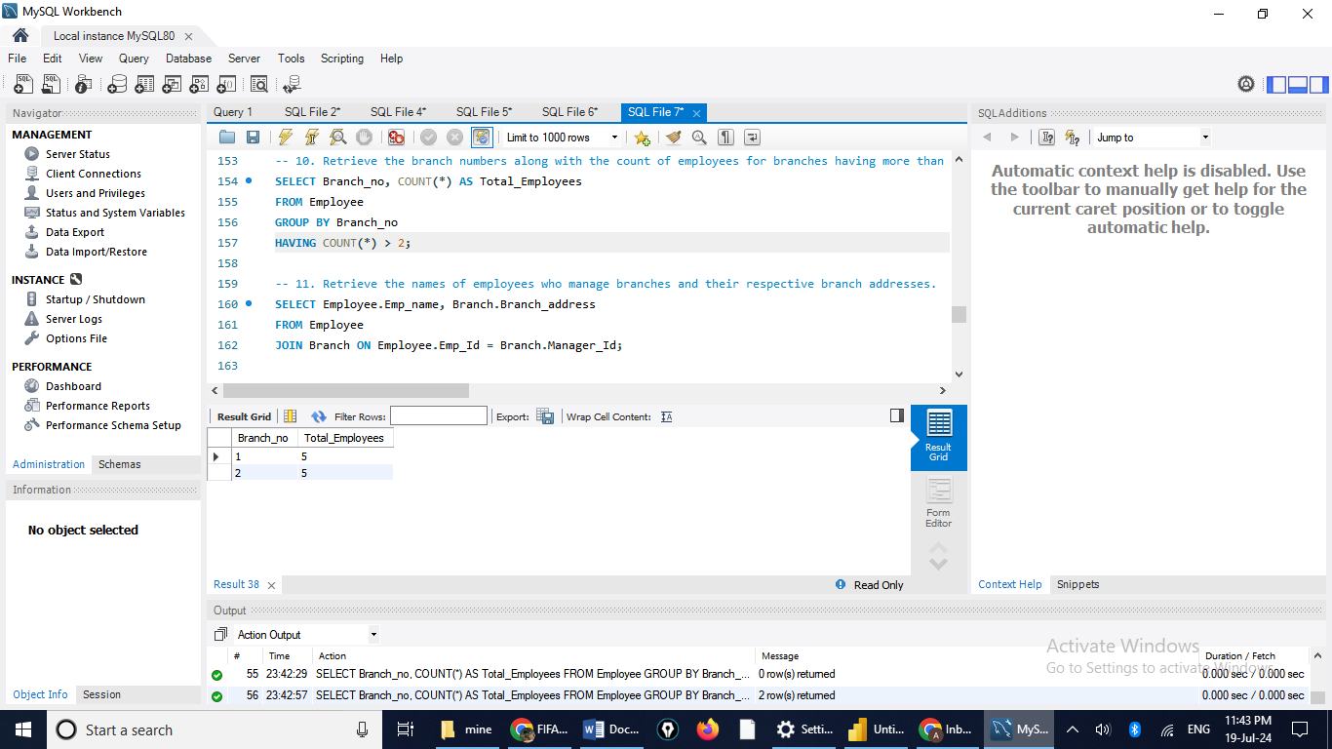  
11. Retrieve the names of employees who manage branches and their respective branch addresses.

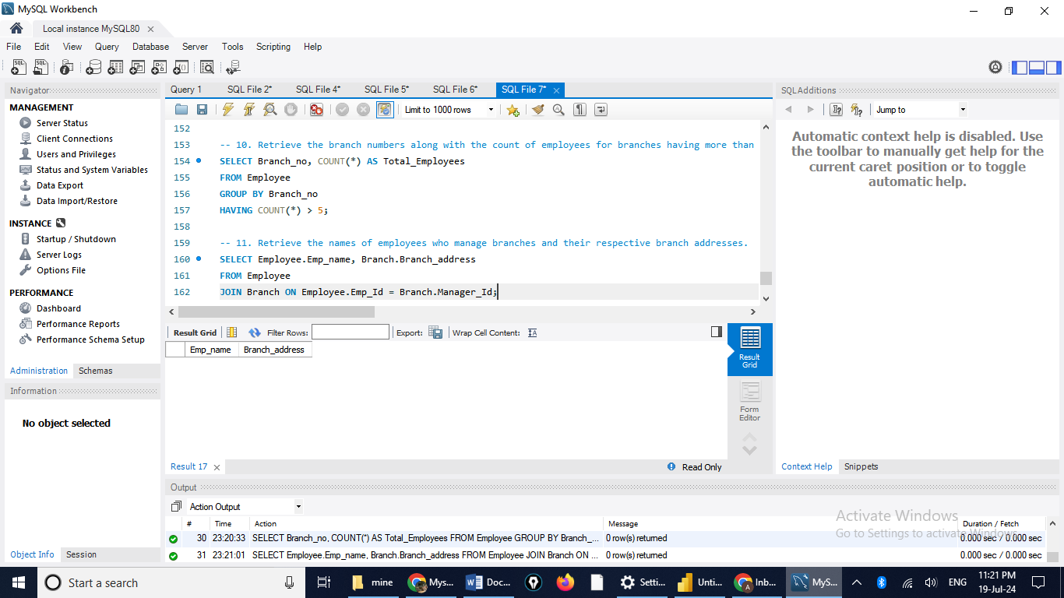  
12.  Display the names of customers who have issued books with a rental price higher than Rs. 25. 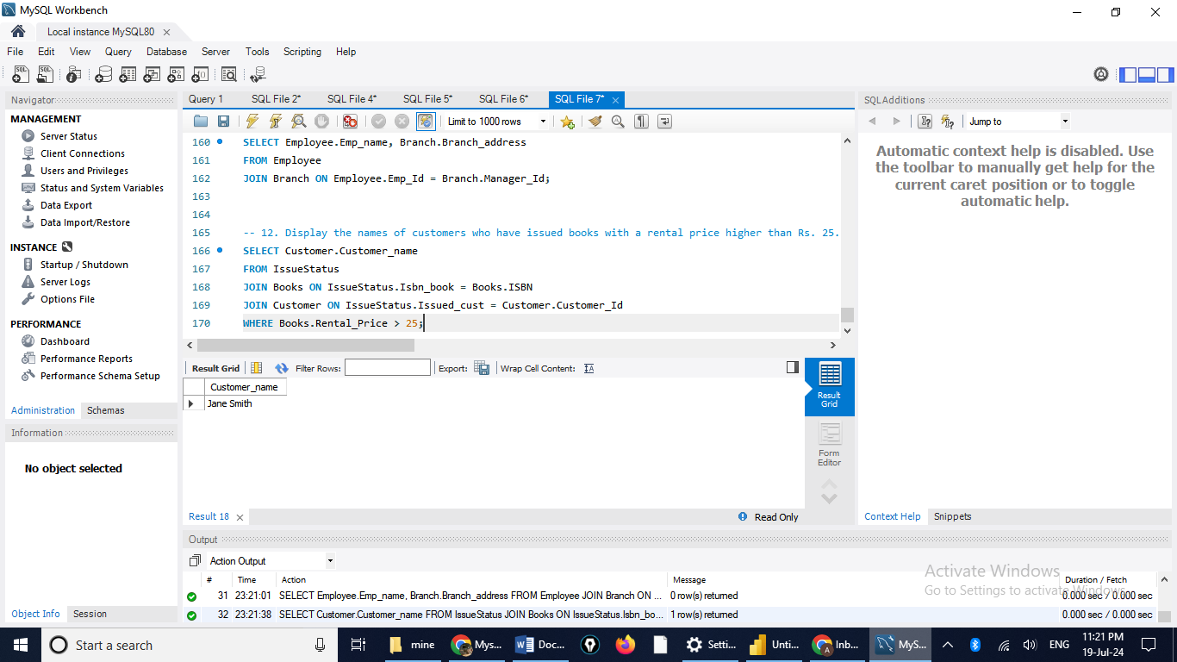  
  
Score Distribution:  
1 point for correctly formulating the query of each question (12 x 1 = 12).  
1 point for providing screenshots of the output for each question (12 x 1 = 12).  
1 point for timely submission.  
Total = 25.  
  
PS : After completing the project upload your project with screenshots in the github and share the link.